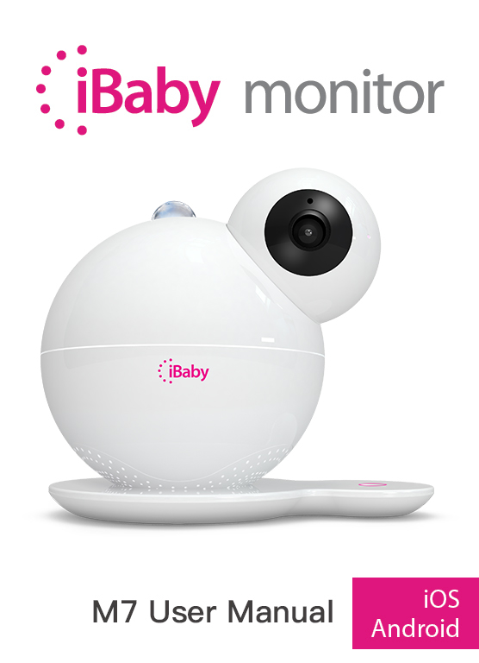

Contents
1 Product Overview 3
1.1 Package List 3
1.2 Interface Introduction 3
1.3 Product Specifications 4
2 Installation Guide 5
2.1 App Download 5
2.2 Getting Started 5
2.3 Register and Login 5
2.4 Device Activation 5
2.4.1 Apple Users Activation 6
2.4.2 Android Users Activation 7
3 APP Operation and Function 9
3.1 The Main Viewing Screen 9
3.2 App Function Menu 11
3.3 Frequently Used Function 12
4 HELP BUTTON ON THE BASE 16
4.1 Moonlight 16
4.2 VOIP 16
5 Frequently Asked Questions 17
5.1 LED Status Light 17
5.2 Installation FAQ 17
5.3 Loading Wheel 20
5.4 Features FAQ 23
6 Contact Information 24
7 FCC Caution 24

Product Overview

Package List
- iBaby Monitor
- Base
- Power Adapter
- User Manual

Interface Introduction
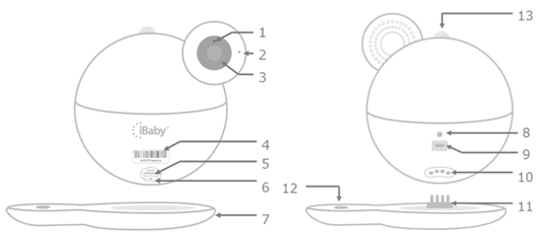
Figure 1
- Night Vision Sensor
- Microphone
- Camera Lens
- Monitor Serial Number：Monitor unique ID, such as “708Qaaaa”
- USB Port: To Install the monitor for iPhone User Only.
- Reset Button：hold for 30 seconds to reset
- Base
- LED Status Light：Shows status of monitor. Refer to Table 1 of Section 4.1
- Power Source
- Temperature/Humidity Sensor：detect temperature and humidity
- Metal prong insert
- Help Button
- Moonlight

Product Specifications
Model:M7
Video | Compression | H.264
 | Frame rate | 1~12 frame
 | Resolution | Ultra (1920*1080),HD(1280*720),VGA(640*480)
 | Camera | Standard：4.0mm F=2.2fixed aperture (3 million camera lens) view angle 87.6°
 | Online users | Support 4 users online simultaneously
Audio | Compression | G711
 | Sampling frequency | 8Kpbs
 | Input | Audio input/built-in microphone
 | Output | Audio output/built-in speaker
 | Intercom | Full duplex ：two-way voice intercom simultaneously
Night vision | Night vision control | Photo resistance control infrared opening automatically (Lowest Illumination 0LUX)
 | Night vision effect | 9 940 LEDs night vision 8 meters
Platform | Control | Built-in motor
 | Rotate angle | Horizontal direction 360°Vertical direction 135°
Network Protocol | Network protocol | TCP/IP，HTTP， UDP， DHCP， UPNP, NTP,P2P
 | Support IP address | Dynamic IP address
Wireless | Wireless protocol | Support Wi-Fi 802.11 a/b/g/n
 | Wi-Fi module | Support 2.4GHz and 5GHz Wi-Fi
 | Encryption | Support WPA/WPA2 encryption
 | Antenna interface | 1
Other Interface | USB interface | 1
 | Temperature/Humidity  module | Built-in 1
 | Reset | 1
 | Projector(Moonlight) | 1
 | Power adapter interface | Micro USB 5V 2A
 | Air quality detection | Ethanol、limonene、acetone、IAQ mixture、butylacetate、toluene、formaldehyde、hydrogen、carbon monoxide、carbon dioxide
Others | Shape material | Plastic
 | Use environment | Indoor
 | Power consumption | Nobody view within 2.5W in the day，Infrared opening within 3W in the evening
 | Work environment | Temperature ：-10~40 °C，Humidity ：40℃ ≤75%
 | Storage environment | Temperature ：-40℃～55℃， Humidity：55℃ ≤90%
 | Size | Monitor size: 132*142*110MM (W x D x H )  Package size: 165*165*165MM (W x D x H)
 | Weight | Gross weight ：2 lbs
System Requirement | Mobile phone operation system | Above iOS 8.0;Above Android 4.0
Certification | Certificate | FCC CE ROSH RCM KC

Installation Guide

App Download
Apple Users：Search on the App Store for“iBaby Care”
Android Users：Search on the Google Play Store for“iBaby Care”
The icon of the app is as follows:
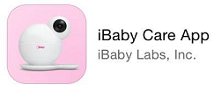

Getting Started
Connect your device to power adapter and wait for the iBaby jingle. The LED light on the back of the monitor will turn to a blinking red light after 30 seconds. The red blinking and jingle indicates that the device is ready for installation.
Note: If the device has been previously activated, it will not jingle when connected to the power adapter.
For the LED status, please refer to Table 1 of section 4.1.

Register and Login
1.New users
Follow the prompt on the app to register an account. Use an active email address and use a password must contain letters (case sensitive) and numbers. The length of it must be over 6 characters. You can have the option to login automatically after registering.
Note: Active email can support users to find their password if they forget.
2.Users with account
Login with email and password you previously registered before. If you forget your password, please click“Forgot Password”to reset your password.

Device Activation
Please confirm that your mobile phone used for activating the device is connected to your Wi-Fi network. And then login with the registered account after the monitor is ready to install.

Apple Users Activation
1.Open the USB cover on the bottom of the device, then connect your iPhone or iPad to the device with the original iPhone USB cable.
2.You will see a “Share Wi-Fi Settings?”prompt on your screen. Once this window shows, click “Allow”. The LED status light will then turn into a blinking green light.
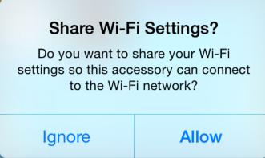
Figure 2
Note:
1) If the prompt does not show, unplug and re-plug the USB cable.
2) If the LED status light does not turn a blinking green, please contact Customer Service or refer to the FAQ of section 4.2 for help.
3.It will show a scene, shown below, on the app after selecting the monitor you have, then click “Next”to activate the device.
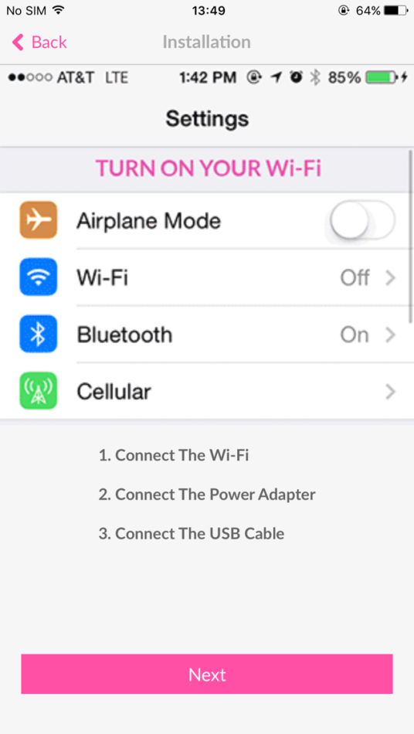
Figure 3
4.Once the device is activated, unplug the USB cable. Put the USB cover back on and place the device on the base.
Note: If you still cannot activate the device, please refer to the “Installation Issues”in section 4.2.

Android Users Activation
1.From the “Add a Device”menu, select the device you want to install.
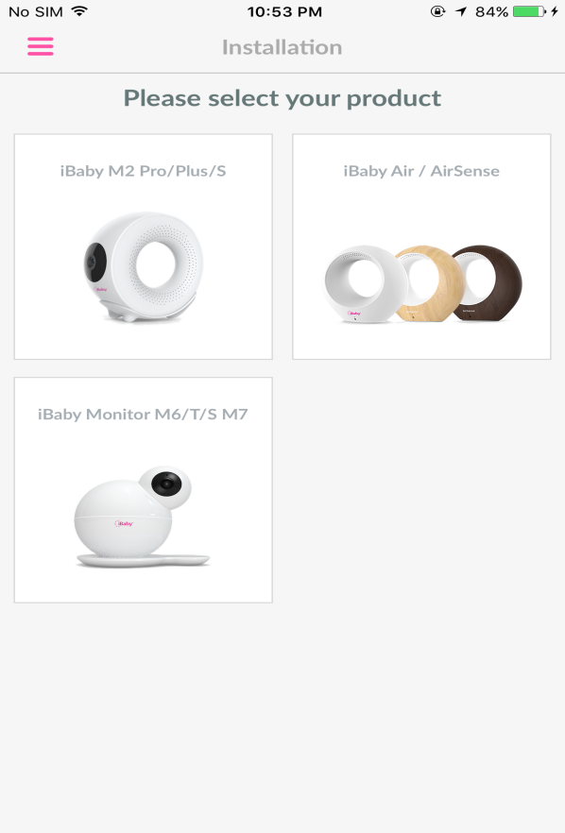
Figure 4
2.Connect your Android device to a Wi-Fi network. Then, connect the power adapter to the monitor. Click “Next”once these steps are completed.
3.The screen will appear as below. Click“Next”after entering the correct Wi-Fi password.
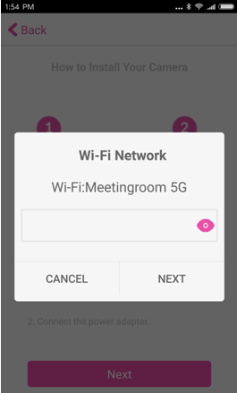
Figure 5
4. The processing bar will fill up to 100%
Note: If you are unable to activate the device, please refer to“Installation Issues”in section 4.2.

APP Function

The Main Viewing Screen

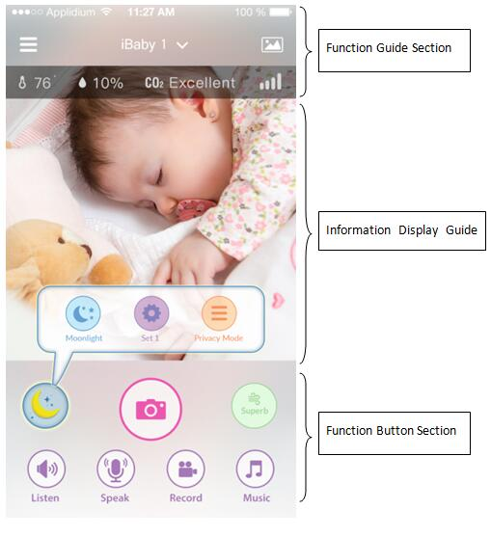
收听：
Figure 6

1.Function Guide
： Function Guide Button: A menu will pop up on the left showing device settings and functions.
：Devices List: Switching different devices using the downward arrow.
： Media Gallery: View all of your saved photos and videos here.

2.Information Display Section

：Current temperature
：Current humidity
：Current carbon dioxide level
：The signal of the Wi-Fi network on the device

3.Function Button Section
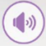： Listen button
： Speak button
： Record button: Captures videos which are saved in the Media Gallery.
： Play button: Plays music from your music library.
： Capture button: Captures photos which are saved in the Media Gallery.
： Air quality icon: It shows the current air quality rating. View previous air quality statistics by clicking on the icon.
： Moonlight icon: Moonlight will turn off automatically after 15 minutes.
：Moonlight button: Tap once to turn the moonlight on. Tap twice to rotate the moonlight 90 degrees. Tap three times to turn off the moonlight.
：Set 1 button: To reset the current camera position, hold down the button for 3s.Touch the button once for the camera to return to the original position.
：Privacy Mode button: Click here to turn on the soothing moonlight effect and the camera will re-position itself towards the ceiling. One more click to turn off the moonlight effect and the camera will automatically rotate to the original position.

App Function Menu
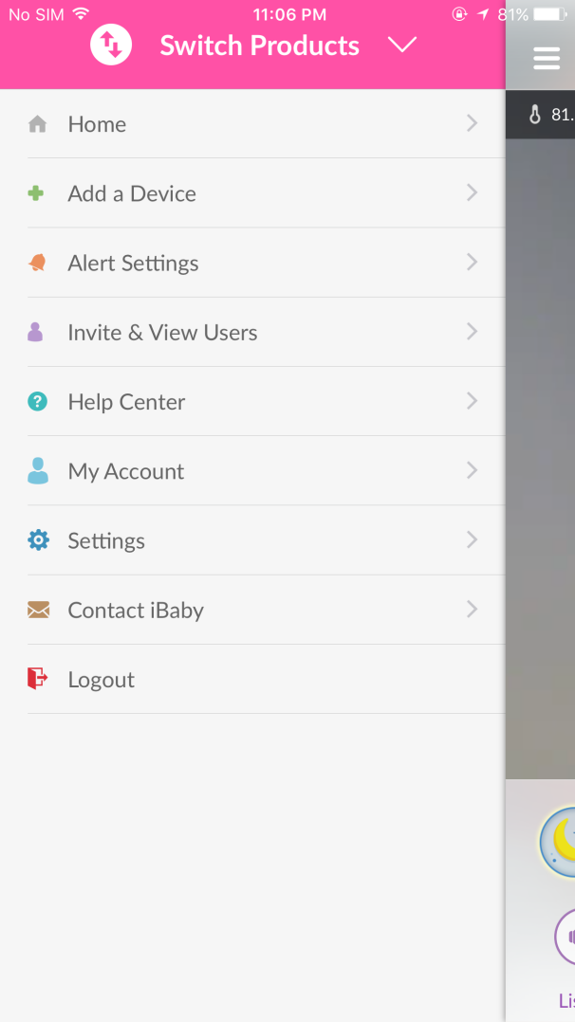
Figure 7
Switch Products:Users can switch between other iBaby devices.
Home: Users can switch to the main viewing screen.
Add a Device: Install a new iBaby device.
Alert Settings: Set the alert notification, alert tone and the specific alert types.
Invite & View Users:I nvite multiple users to view your monitor give the access to users.
Help Center: Answer the frequently asked questions.
My Account: Set and display the personal information.
Settings: Set the parameters and functions on the device.
Contact iBaby: Contact iBaby for support or just send your feedback.
Logout: Log out.

Frequently Used Function
    - Alert Settings
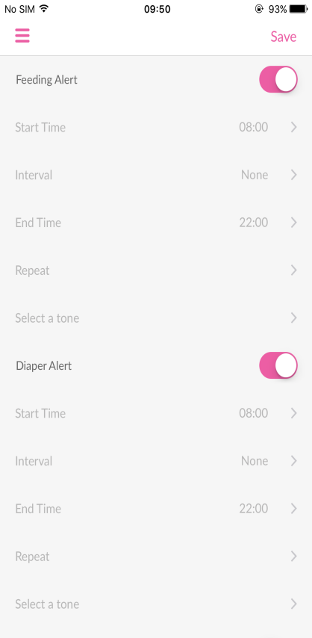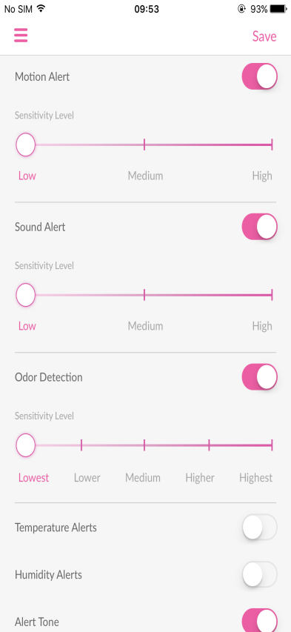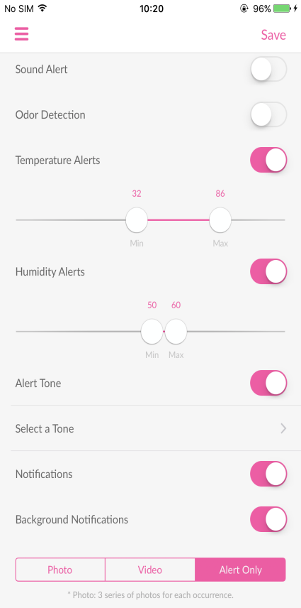

Figure 8
Feeding Alert: You can set this to remind yourself to feed for your child. It will remind you when times up.
Diaper Alert: You can set this to remind youto change the diaper of your child. It will remind you when times up.
Motion Alert: The device will trigger an alert when motion detected. The higher the sensitivity level, the more accurate the monitor will be.
Sound Alert: The device will trigger an alert when there is a sound from the room. The higher the sensitivity, the more accurate the monitor will be.
Odor Detection: The device will trigger an alert when the air quality in the room changes. The higher the sensitivity level, the more accurate the monitor will be.
Temperature Alerts: The device will trigger an alert when the temperature around the device is below the minimum value (eg.32℉) or above the maximum value (eg.86℉).
Humidity Alerts: The device will trigger an alert when the humidity around the device is below the minimum value (eg.50%) or above the maximum value (eg.60%).
Alert Tone:Select a tone for the alerts.
Notifications:If this setting is on, you will get notifications when the app is running.
Background Notifications:If this setting is on, you will get notifications when the app is closed or running in the background.
Alerts display types:
Photo: When there is an alert the device will capture 3 photos and save them in the Media Gallery.
Video: When there is an alert, the device will capture a 15 second video and save it in the Media Gallery.
Alert Only: There is only notification without any media file saved.

    - Invite & View Users
You can invite unlimited friends to have access to the monitor. As for specific steps, please refer to “Q2”of section 4.4.

    - Settings -> Display Settings
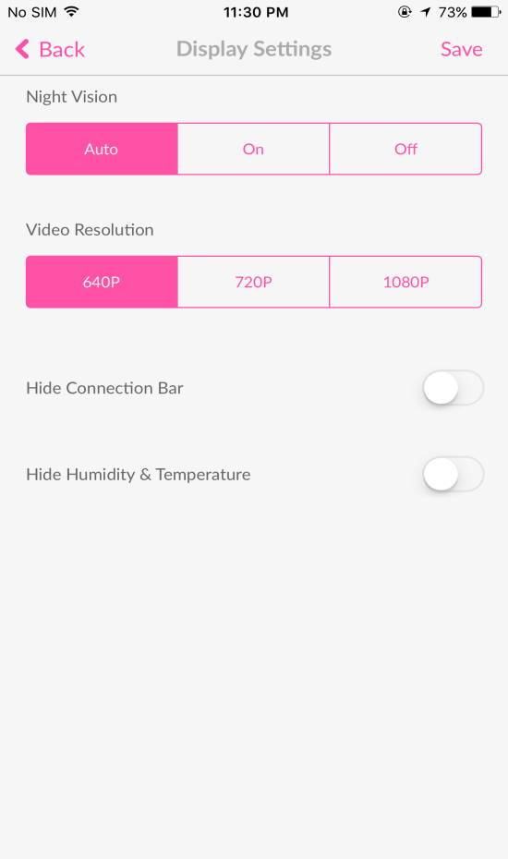
Figure 9
Night Vision:
Auto: The image on the screen will turn into colored/black and white according to the light intensity automatically. This is the default setting.
On: Night vision will always be on and the image on the screen will be in black and white.
Off: Night vision will always be off and the image on the screen will be in colored.

Video Resolution:
Fair 640P:The image quality is fair (it corresponds with 640P). It produces less than 128kbps’ data per second with low bandwidth occupied.
Good 720P: The image quality is good (it corresponds with 720P). It produces less than 256kbps’ data per second with medium bandwidth occupied.
Excellent 1080P: The image quality is excellent (it corresponds with 1080P).It produces less than 512kbps’ data per second with high bandwidth occupied.

Hide Connection Bar: Hide the Wi-Fi network signal on the main viewing screen.
Hide Humidity & Temperature:Hide the humidity & temperature on the main viewing screen.

    - Settings ->Sleep Mode
When the Sleep Mode is on, other users cannot access or view the monitor.
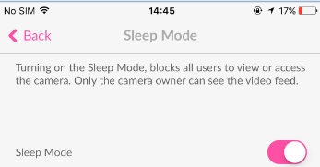
Figure 10

    - Feedback Settings =》Shake to report bug
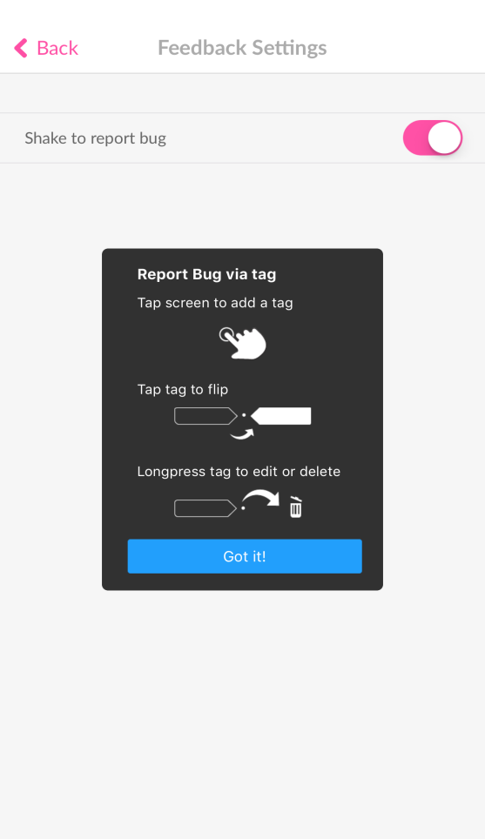
Figure 11
Report Bug via tag: Tap screen to add a tag=》Tap tag to flip=》Longpress tag to edit or delete.

    - Play Music
A collection of pre-loaded music. Simply select any of the media files to play through the iBaby device speakers.
Note:Because the music is streaming over the Internet, they might not play (or will be delayed) when the network connection is poor. Please check your network settings if you have streaming issues.
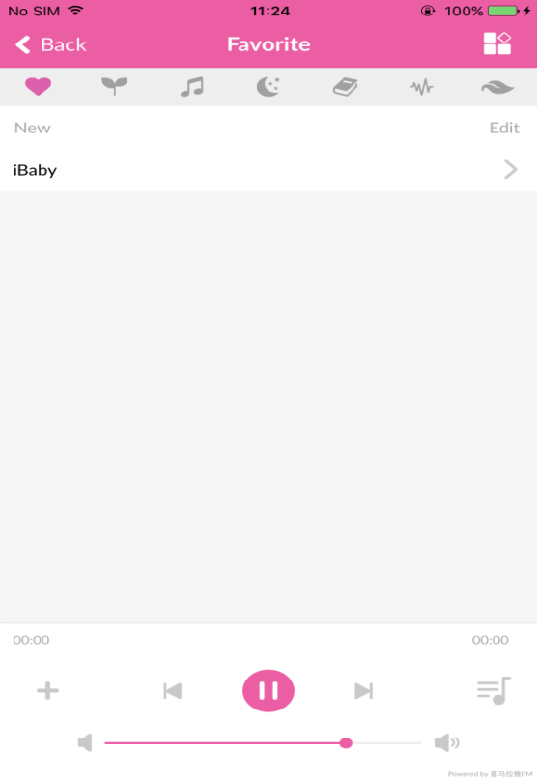
Figure 12

    - Camera & App Information
It shows the camera and app information, including firmware version, app version, S/N, etc.
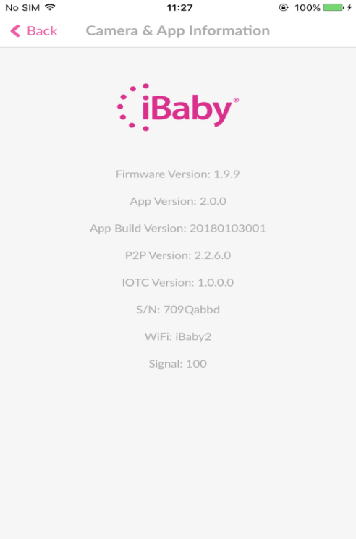
Figure 13

Help Button On The Base
4.1 Moonlight
One click for moonlight display projection. Two clicks for rotating moonlight display projection. Three clicks to turn off moonlight display.
4.2 VOIP
Hold for five seconds to start your 2-way audio call.
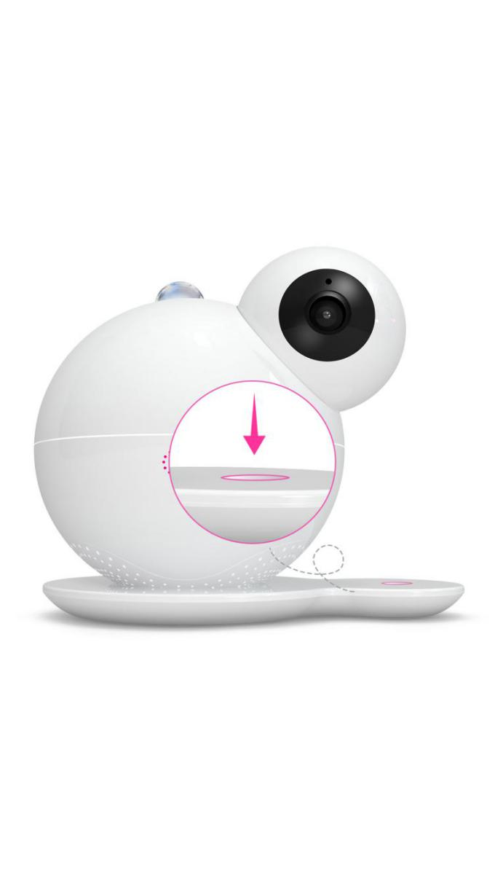
Figure 14

Frequently Asked Questions

5.1 LED Light Status
LED status | Monitor Status
A blinking red light | Device is not connected to Wi-Fi and not activated
A blinking green light | Device is connected to Wi-Fi, but not activated
A steady red light | Device is not connected to Wi-Fi, but has been activated
A steady green light | Device is working properly
Red and green blinking alternately | Device is starting
No light | The power adapter is not plugged or there is an issue on the device
Table 1

5.2 Installation FAQ
Q1.iOS Device:
Click “Cancel”when you see a prompted message“If You Do Not See Any Progress”as shown below (the LED status light on the back of the monitor is a blinking red light).
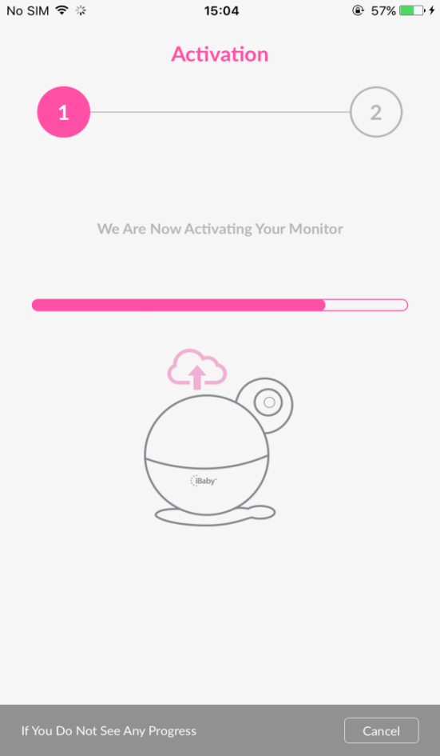
Figure 15
If this prompt shows, it may be that the monitor is not connected to your Wi-Fi network. Please follow the steps as below:
1)Please use the phone’s original USB cable to enable a great connection.
2)Place the monitor near the router as close as possible while installing. If your router supports 5GHz, we recommend that your connect your phone to the 5GHz Wi-Fi before installation.
3)The best Wi-Fi name & password should be 8-32 characters comprised of upper and lower-case letters, numbers, and underscores. And they should not contain symbols or special characters such as Chinese, Japanese, Korean, etc.
4)Enable your router’s SSID to be broadcast, not hidden.
5)Select WPA2-PSK as the Wi-Fi authentication type and select AES as the encryption type on the router.

Q2.Android Device:
There is a prompted message indicates installation failed. Why? (the LED status light on the back of the monitor is a blinking red light)
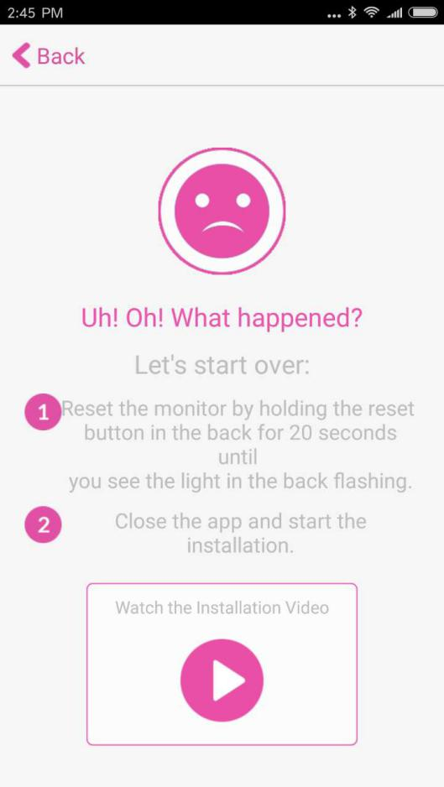
Figure 16
It indicates that your monitor has not connected to your Wi-Fi network. Please follow the steps as below:
- Verify that the Wi-Fi password you enter is correct. Unplug the power adapter, and then plug back it to reinstall.
2) Place the monitor as close to the router as possible during installation. If your router supports 5GHz, we recommend connecting to the 5GHz Wi-Fi.
3) The best Wi-Fi name & password will be 8-32 characters comprised of upper and lower-case letters, numbers, and underscores. And they should not contain symbols or special characters such as Chinese, Japanese, Korean, etc.
4) Enable your router’s SSID broadcasting.
5) Select WPA2-PSK as the Wi-Fi authentication type and select AES as the encryption type on the router.
Note:
Installation starts immediately after you enter the password. The monitor will jingle when the installation progress bar reaches around 5%. There is a steady green light after the installation is completed.
You’d better place the monitor near the router as close as possible if the monitor does not jingle. Restart the router to reinstall the monitor. You can reinstall the monitor at another time if available.

Q3.Click “Cancel”when you see a prompted message“If You Do Not See Any Progress”(the LED status light on the back of the monitor is a blinking green light).
It indicates that your monitor has connected to your Wi-Fi network, but it is not activated on the server. Please exit the app in the background and then reopen it. Both the monitor and the router need to restart. If the installation fails again, please re-install the monitor, but do not reset the monitor.

Q4. Cannot go to the next step while adding a device. Why?
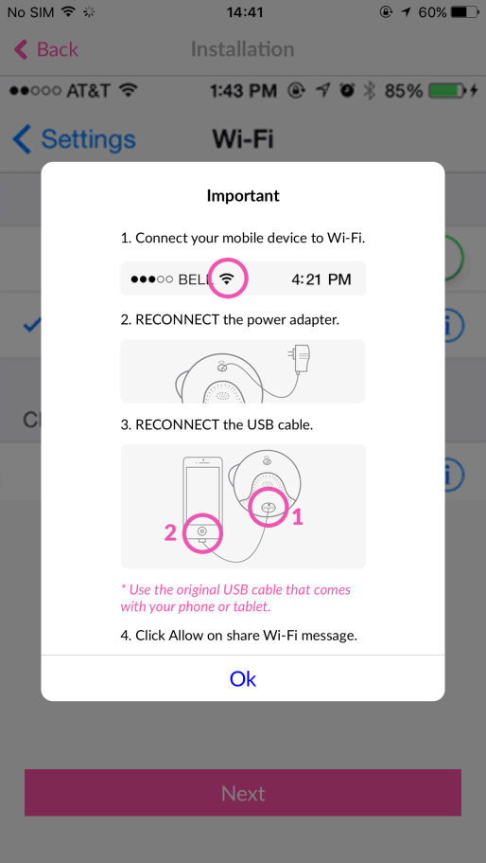
Figure 17
There are some tips to follow:
1)Please use the iPhone’s original USB cable.
2)Verify that your phone has connected to your Wi-Fi network.
3)The power adapter has been plugged and the device has started (the LED status light on the back of the monitor is a blinking red light).
4)Unplug the power adapter and then plug back it.

Q5. How to install the monitor when the Wi-Fi settings have been changed?
iOS Device:Please use the USB cable to connect your iOS device and the monitor. And then click“Allow”when you see a prompted message “Share Wi-Fi Settings?”.
Android Device:Reset the monitor and then reinstall it. As for the specific steps about reset, please refer to “Q6” of section 4.4.

Q6. What should you do if you forget your password?
When you forget your login password, please enter the email address you used at registration, and then click “Send”. There will be a link sent to your mailbox which is used for resetting your login password. Please click the link to reset the login password within 1 hour.
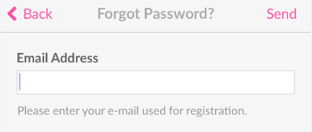
Figure 18

5.3 Loading Wheel
Q1.It is very slow on the main viewing screen when viewing at home(the LED status light on the back of the monitor sometimes is a steady green light, and sometimes it is a steady red light).
When the LED status light is a steady red or green light, it indicates an unstable Wi-Fi connection. You should optimize the Wi-Fi settings by following the tips as below:
- If you have a dual band router, we recommend that your monitor connects 5GHz Wi-Fi .
2)If you use a regular router on 2.4GHz,you can login to the router to optimize the Wi-Fi settings. Select 20M as the bandwidth if it is a TP-Link router(if it is a NETGEAR router, enable 20/40MHz coexistence).
3)If the router is far away from the monitor(or there are multiple walls between the router and the monitor),please place the monitor near the router as close as possible to have a try.
4)The router might have a heavy load, please unplug the power cord of the router and then plug back it to restart.

Q2.If it gets stuck on a loading screen while viewing at home and the LED status light on the back of the monitor is a steady red light.
Figure 19
It indicates that your monitor has not connected to your Wi-Fi network. Please follow the steps below:
- Unplug the power adapter of the monitor and then restart to check whether the LED status light turns into a steady green light.
- The router might have heavy load, please unplug the power cord of the router and then plug back it to restart.
3)If the router is far away from the monitor( or there are multiple walls between the router and the monitor),please place the monitor near the router as close as possible to have a try.
4)If the LED status light is still a steady red light, it indicates that the Wi-Fi password might have been changed. Please reinstall the monitor.

Q3.You can control the 360° pan’s movement and hear the sounds while viewing at home.But the main viewing screen shows a black screen at this moment(the LED status light on the back of the monitor is a steady green light).
Figure 20
It indicates that your monitor has connected to your Wi-Fi network, but the bandwidth is not high enough to load videos. Please follow the steps below:
1)The router might have heavy load, please unplug the power cord of the router and then plug back it to restart.
2)Unplug the power adapter of the monitor and then restart.
3)Please close the app in the background and then reopen it.
4)The router is far away from the monitor, or the Wi-Fi signal is disturbed badly by other Wi-Fi signal around it. If you have a dual band router, we recommend that your monitor connects 5GHz Wi-Fi .If you use a regular router on 2.4GHz, you can login to the router to optimize the Wi-Fi settings. Select 20M as the bandwidth if it is a TP-Link router(if it is a NETGEAR router, enable 20/40MHz coexistence).

Q4.The monitor works properly while viewing at home Wi-Fi, yet slow while viewing on 4G LTE network.
It has the same network bandwidth requirement on both watching movies and viewing the monitor. Both the network connected with the monitor and the network connected with the phone should be great.
- Adjust the video resolution.
- Please close the app in the background and then reopen it.
3)Unplug the power adapter of the monitor and then restart.

5.4 Features FAQ
Q1.There is so much noise after clicking the Listen and Speak button at the same time.
The phone is too close to the monitor. Please lower the crosstalk by placing the monitor 10 meters or more away from the phone.And there will be no noise if you view the monitor outside your home.

Q2.I am the owner, how do I invite users to view the monitor?
There are some tips to follow:
1)The invited user must first register an account by downloading the iBaby Care App and registering the email they want to share with the owner of the iBaby monitor.
2)Once the guest has registered an account, the owner can then proceed by clicking “Invite & View Users”on the iBaby Care App. Insert registered email for the invitee and complete by simply pressing the“Send Invitation”bar.Please see Figure 19.
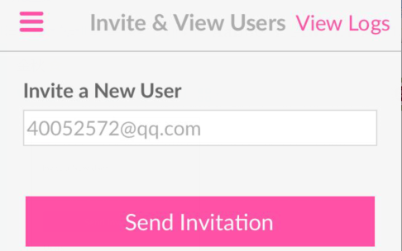
Figure 21

3)Close the app in the background and then reopen it on the user’s phone.
Note: The monitor is bound with the owner’s account and the user’s account at the same time after that.

Q3.The picture on the main viewing screen is fuzzy, how do I adjust the video resolution?
You can adjust the video resolution by clicking“Settings”on the app function menu. And then click “Display Settings”.
Excellent 512kbps:The image quality is excellent(it corresponds to 1080P).It produces less than 512kbps’ data per second with high bandwidth occupied. For iPhones, the pictures are magnified when viewing vertically. We recommend viewing horizontally for clearer pictures and full vision coverage.

Q4.Why cannot I see the previous alert’s photos and videos?
Both the alert’s photos and videos are saved on the server. The previous alert’s photos and videos will be removed when there are more than 100 records. Alert’s videos occupy high bandwidth, so we recommend selecting alert’s photos when the network is not great.

Q5.There is no humidity & temperature display.
Here are some tips to follow:
Check whether the monitor is placed on its base properly or not.
The humidity& temperature module is built in the magnetic base. You should aim the monitor at the four metal prongs on the base and place the monitor smoothly. It is a good sign if the monitor can stay attached to the base when you pick up the monitor.

Q6.How to reset the monitor(reset to the default state)?
Press the reset button on the bottom of the monitor until the LED status light is red and green blinking alternately (multiple times per second).The LED status light will turn into a blinking red light(one time per second) when the monitor jingles.The reset is completed after that.

Contact Information
Customer Service Hotline：1-650-396-2436（Monday – Friday: 9 am – 5 pm PT）
E-mail：support@ibabylabs.com
Website：https://ibabylabs.com

FCC Caution
Any Changes or modifications not expressly approved by the party responsible for compliance could void the user's authority to operate the equipment.
This device complies with part 15 of the FCC Rules. Operation is subject to the following two conditions: (1) This device may not cause harmful interference, and (2) this device must accept any interference received, including interference that may cause undesired operation.
This equipment has been tested and found to comply with the limits for a Class B digital device ,pursuant to part 15 of the FCC Rules. These limits are designed to provide reasonable protection against harmful interference in a residential installation. This equipment generates uses and can radiate radio frequency energy and, if not installed and used in accordance with the instructions, may cause harmful interference to radio communications. However, there is no guarantee that interference will not occur in a particular installation. If this equipment does cause harmful interference to radio or television reception, which can be determined by turning the equipment off and on, the user is encouraged to try to correct the interference by one or more of the following measures:
‐Reorient or relocate the receiving antenna.
‐Increase the separation between the equipment and receiver.
‐Connect the equipment into an outlet on a circuit different from that to which the receiver is connected.
‐Consult the dealer or an experienced radio/TV technician for help.
FCC Radiation Exposure Statement:
This equipment complies with FCC radiation exposure limits set forth for an uncontrolled environment .This equipment should be installed and operated with minimum distance 20cm between the radiator& your body.
This transmitter must not be co‐located or operating in conjunction with any other antenna or transmitter.
Wi-Fi 5G indoor use only !
Operations in the 5.15‐5.25 GHz band are restricted to indoor usage only.

